Atitit bug报告

住院医生》》开医嘱 ，查看看医嘱

点击一条医嘱时的ajax url

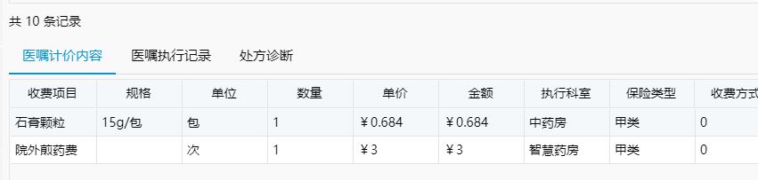

<http://192.168.1.18:8081/hosdoctorweb/cloud/doctorordernew/getOrderlistvaluation?lVAFID=956098328192356353&lVAF01A=0>

返回

{"result":"Success","resultMsg":null,"list":[{"rownr":1,"bby01":6104,"bda01":"3","vaf21":1.0000,"vaf22":"石膏颗粒","bby04":"900250","aas02":"甲类","bby06":"15g/包","vaf59":1,"lmoney":0.68400000000000,"bdu10":0,"bby08":"包","bck03":"中药房","bck01":73,"lprice":0.6840000000},{"rownr":2,"bby01":12291,"bda01":"T","vaf21":1.00000000,"bby04":"99250302006","aas02":"甲类","vaf22":"院外煎药费","vaf59":1,"lmoney":3.00000000000000,"bdu10":0,"bby08":"次","bck03":"智慧药房","bck01":116,"lprice":3.000000}],"commList":null,"map":null,"resultObj":null,"total":2,"recordsTotal":0,"recordsFiltered":0,"data":null,"footer":null,"page":1,"records":0,"totalPage":0,"pagenumber":1,"userdata":null,"rows":null,"tableField":null}

<http://localhost:8080/hosdoctorweb/cloud/doctorordernew/getOrderlistvaluation2?lVAFID=974115181288230912&lVAF01A=974115181288230913>

**public** ModelVo selectOrderlistvaluation2(Map map){

**return** MySqlUtil.*packModelVo*("Doctorordernew.1428",map,doctorordernewDao);

}

/**

* 封装普通list数据

* **@param** nid mybatis SQL编号

* **@param** map 查询传参map

* **@param** baseDao 数据查询接口

* **@return**

*/

**public** **static** ModelVo packModelVo(String nid,Map map,BaseDao baseDao){

ModelVo **mo** = **new** ModelVo();

List<Map<String,String>> **list** = **null**;

**try** {

list = baseDao.queryForList(nid,map);

} **catch** (Exception **e**) {

e.printStackTrace();

}

**if**(list!=**null**&&list.size()>0) {

mo.setList(list);

mo.setResult(StaticKeys.***OH_SUCCESS***);

mo.setTotal(list.size());

}

**return** mo;

}

/**

* 功能：查询获取查询结果

* **@param** sqlDef sql语句的定义名称

* **@param** param 查询所要用到的参数

* **@return** List对象，里面是VO对象。

*/

@SuppressWarnings({ "rawtypes", "unchecked" })

**public** List queryForList(String sqlDef, Object param)**throws** Exception{

List **ls** = getSqlSession().selectList(sqlDef,param);

**if**(**null**==ls){

ls = **new** ArrayList();

}

ls.removeAll(YHDCollectionUtils.*nullCollection*());

**return** ls;

}

/clinical/src/main/java/com/cnhis/cloudhealth/clinical/hosdoctor/doctorordernew/mapper/doctorordernewMapper.xml

<!-- ScriptId(1428) 医嘱列表-医嘱计价内容2-->

<select id="1428" parameterType="map" resultType="myHashMap">

<![CDATA[

SELECT b.BBY05 AS VAF22,a.VAF21,d.BCK03,d.bck01,e.AAS02 ,b2.BDG02B as BBY08,0 BDU10,

CASE WHEN f1.BBY01 IS NOT NULL AND g1.BCH01 IS NULL THEN (b.BBY25*b2.BAG07*f1.ACV08)/f1.ACV09

WHEN f1.BBY01 IS NULL AND g1.BCH01 IS NOT NULL THEN (b.BBY25*b2.BAG07*g1.ACV08)/g1.ACV09

ELSE b.BBY25*b2.BAG07 END AS lPrice,

CASE WHEN f1.BBY01 IS NOT NULL AND g1.BCH01 IS NULL THEN (b.BBY25*b2.BAG07*f1.ACV08*a.VAF21)/f1.ACV09

WHEN f1.BBY01 IS NULL AND g1.BCH01 IS NOT NULL THEN (b.BBY25*b2.BAG07*g1.ACV08*a.VAF21)/g1.ACV09

ELSE b.BBY25*b2.BAG07*a.VAF21 END AS lMoney,

a.BDA01,a.VAF59,a.Rownr,b.BBY04,b.BBY01,b.BBY06

FROM VAF2 a

JOIN BBX1 a2 ON a.BBX01 = a2.BBX01

JOIN BBY1 b ON a.BBY01 = b.BBY01

JOIN BAG1 b2 ON b.BBY01 = b2.BBY01

JOIN BDA1 c ON a.BDA01 = c.BDA01

JOIN BCK1 d ON a.BCK01B = d.BCK01

JOIN VAE1 a3 ON a.VAF06 = a3.VAE01

Left JOIN AAS1 e ON b.AAS01 = e.AAS01

LEFT JOIN (SELECT f.ABC02,f.BBY01,f.A